Prediction of fetal wasted

* Data preparation: the data was prepared in such a way that we would be predicting the rate (r) of fetal wastage.
  + r = $\frac{fetal wastage}{total slaughtered}$
  + the data was then divided into two sets, training data and evaluation data in the ratio of 7:3 i.e 70 % for training, 30% for evaluation.
  + Using the Data.java class the data was read into a FeatalHistory.java class. Each record being an instance of featalHistory.
* Neural Network (NN): The neural network was structured for regression purposes
  + Structure: the neural network consists of a group of computational nodes arranged to model the biological neural connections, although in a more primitive way. Neural Networks can be grouped into different types, based on how their “neuron” are arrange relative to one another, examples include, Multi-layer perceptron, Hopfield, etc. For this work the Multi-layer perceptron structure was adapted. The multi-layer perception has it neurons grouped into three distinct layers, input, hidden and output.
  + Input layer: this layer consists of neurons that interact with the environment in other to get data into the neural network. Our input consists of 7 neurons.
  + Hidden layer: The hidden layer interfaces with both the input and output layer. It helps with the propagation of the input signal to conform to the expected output signal. Our hidden layer consists of 7 neurons
  + Output layer. The output layer consists of neurons that conveys the final result, the transformation of the input variables to the output. Our output layer has 1 neuron.
  + Training: The neural network must be trained to perform a particular task. There are 3 types of training, supervised training, unsupervised, semi-supervised. Unsupervised the neural network is left to group the data based on the number of groups expected and how closely related to a group the data is. Supervised the neural network is provided with the correct data and it is trained in such a way as to mimic the trend in the data. This is achieved by using a training algorithm, whose aim is to minimize the error between the neural network output and the expected actual output. The Resilient Propagation algorithm was employed.
  + Evaluation: This is done after the NN has been trained this helps to evaluate how well the NN has learned the trend in the data.
  + Encog 3.0: Encog 3.0 is a Machine learning library written in java. This library was used to build the neural network. The library is included in the zip folder.
  + Limitations: The neural network has some limitations
    - The NN is a general approximator, it cannot be relied upon to give an accurate output. The neural network is ineffective on data that has a definite sequential or linear process.
    - The NN generally tends to perform better has the volume of data increases. The data used for this work is not sufficient for the neural network. This is due to the poor record keeping of most our government parastatals. Hence the result gotten from this work is very poor and a poor representation of the power of the NN in regression analysis. We encourage an improvement in record collection and keeping in our various government parastatal.
* Netbeans is the software.
  + Install netbeans
  + Click on file -> Open project

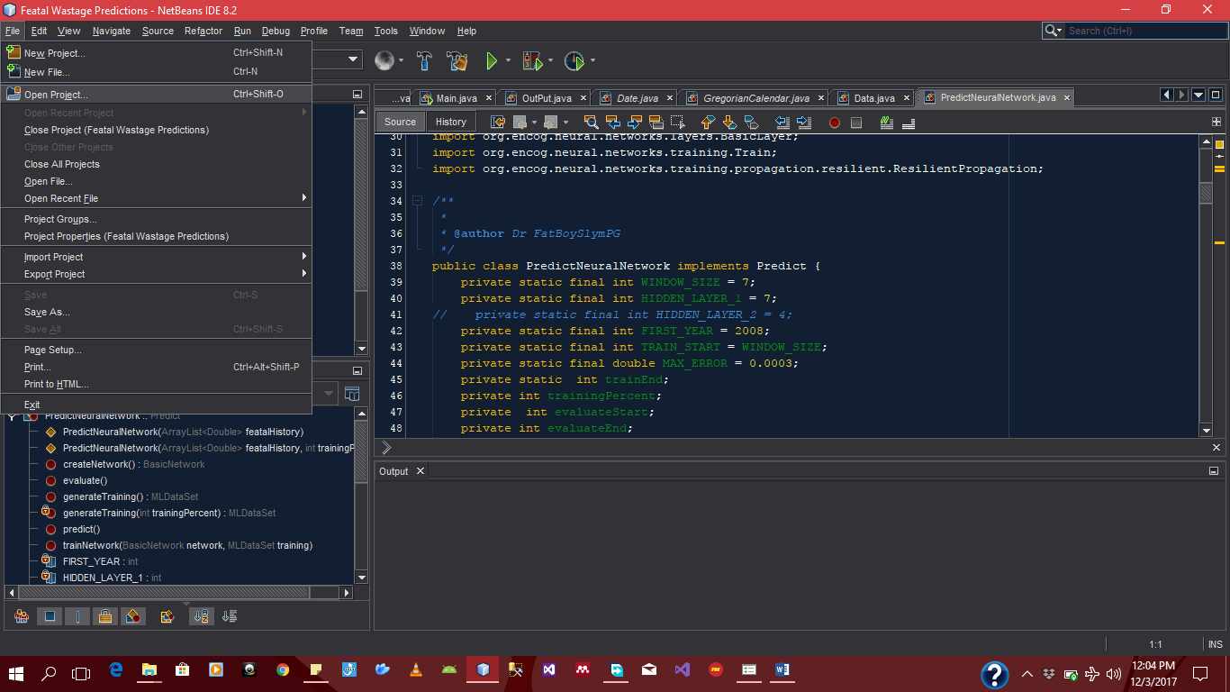

* + Browse to where you placed the featal wastage folder
  + Select the featalWastagePrediction and click open Project

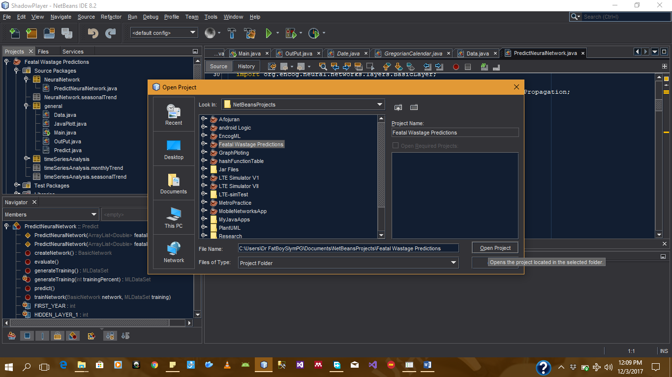

* + At the sidebar you see Projects tab, expand the general package, right click on the Main.java file and click run.
  + The result is written to a csv file in the output folder “Featal Wastage Predictions\data\Output” EvaluteNN.csv contains the evaluation data, predictNN contains the prediction for two years. trainingEpoch_Error.csv contains the data for training i.e number of training and Error recorded.
  + You can plot the graphs has previously shown you from the excel files generated.

To download Netbeans google netbeans download and download any of the netbeans packages

* Incase of any question egbon you can reach me on phone. Sorry for the inconveniences. Thank you.